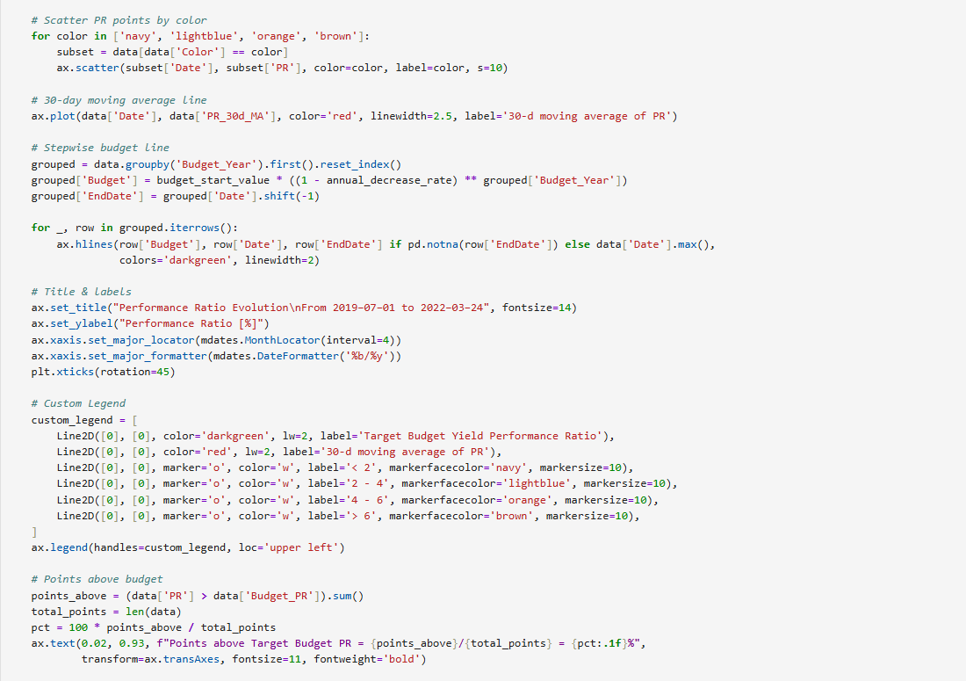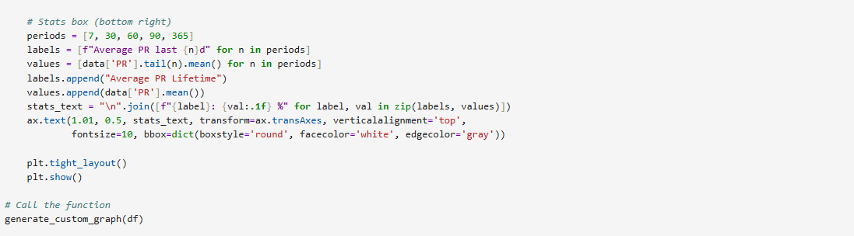

**Coming to Data of Performance Ratio & Global Horizontal Irradiance**

Generate a single CSV file containing all the data from both the PR and GHI folders. The new CSV file should contain 3 columns: Date, GHI, PR

I did every thing manually in google sheets

By combining all the sheets first and removing the duplicate values in that and repeated heading in the data

And I finally sorted the data according to date, time format

**Data Visualization:**

**KPIS**

- Create a single function to generate the graph. Make sure you organize your code and it is readable.

- The red line on the graph represents the 30-d moving average of the PR (Performance Evolution) whereas the position of the scatter points depict the PR value of that day and the colour shade depicts the GHI value.

- The dark green line represents the budget line. The value begins from 73.9 and should reduce by 0.8% every year (Do not hardcode the values). As you can see, the values are: o 73.9 for the first year (July 2019 to June 2020) o 73.1 for the second year (July 2020 to June 2021) o 72.3 for the third year (July 2021 to June 2022) This should happen dynamically via code.

- The points for the scatter plot are color-coded (as per the legend). If the GHI [Daily Irradiation] is: o Less than 2: Navy blue o 2-4: Light blue o 4-6: Orange o >6: Brown

- The points above Target Budget PR represent the number of PR points above the Budget PR for that particular year.

- The bottom right section of the graph simply shows the average PR for the last 7 days, the last 30 days, the last 60 days, and so on. - Please note that the values and the trends will not match the graph exactly since we have changed the data slightly.

**\* I taken all these points into consideration and created this graph visualisation\***.

Bonus

**Kips**

Enhance the script to accept start and end date arguments for generating a PR graph based on the specified date range. For example, you could run the script with start date: “2024-01- 01” and with end date “2024-06-30” to visualize PR data between January 1, 2024, and June 30, 2024.

We don’t have data for 2024 so I take data from 2021 to be clear here is the graph below

